

**Subject: Software Engineering**

**Subject code: IT632**

**Final Assignment - Deliverable Code : 05**

Date of submission: 02-05-2023

Due date of submission:02-05-2023

**Name: Dev Adnani**

**Topic: Zoom Video Conference Application**

Activity Diagram

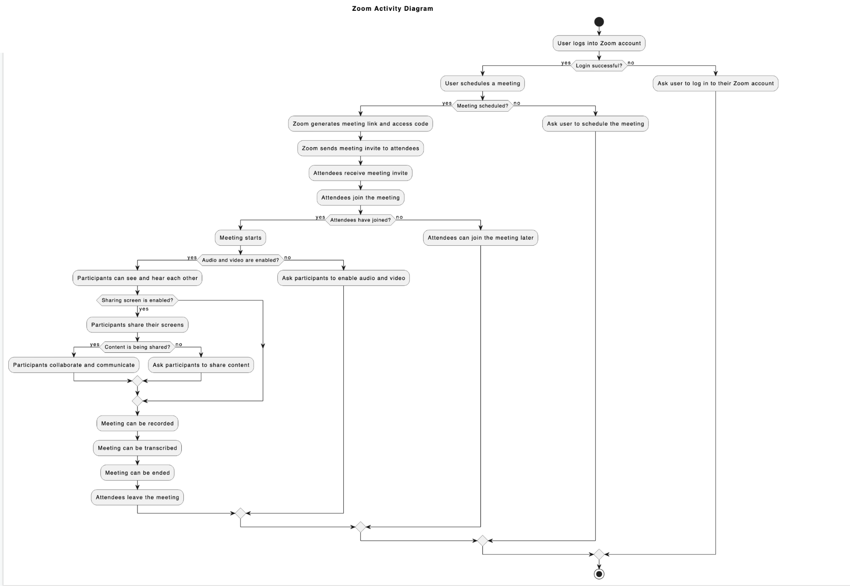

Use Case Diagram

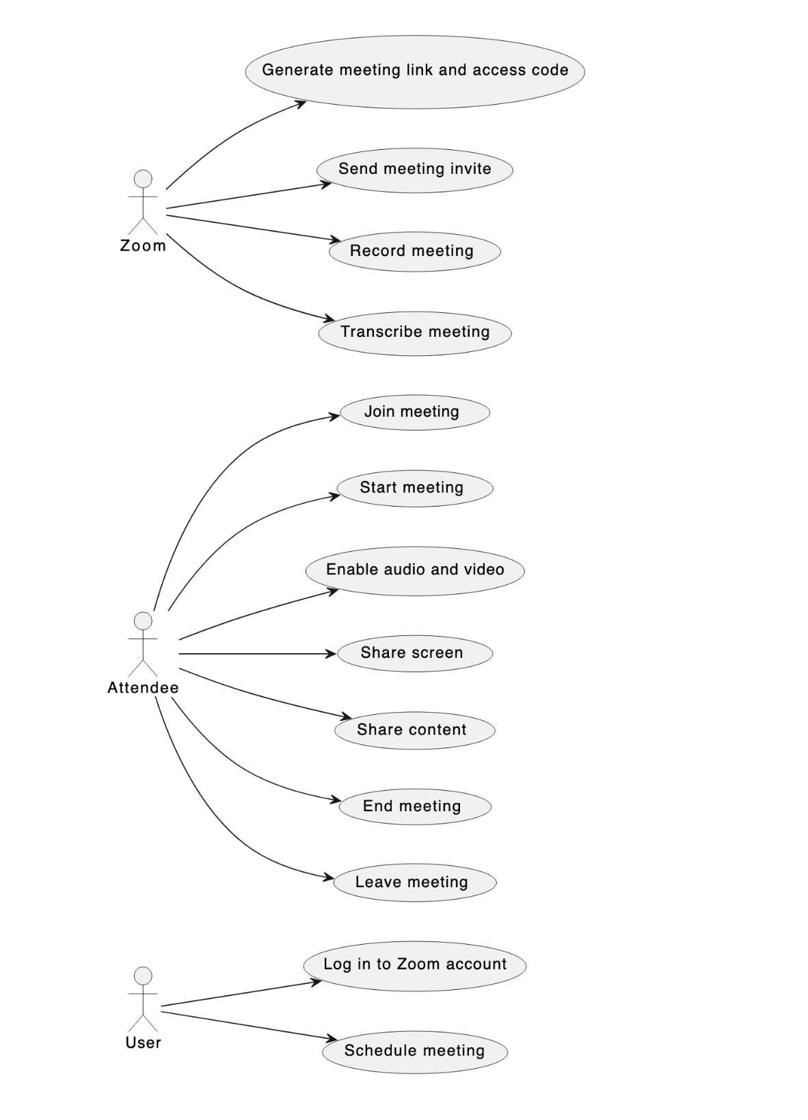

**Use Case Diagram (Textual Format)**

| Use Case | Log in to Zoom account |
| --- | --- |
| Actors | User |
| Description | User wants to log in to their Zoom account. |
| Precondition | User has access to the Zoom account. |
| Basic Flow | * User opens the Zoom login page. * User enters their email address and password. * User clicks on the "Login" button. * Zoom verifies the email address and password. * Zoom redirects the user to their account dashboard. |
| Alternative Flow | If the email address and password are incorrect, Zoom displays an error message and prompts the user to enter the correct credentials. |
| Post Condition | User is logged in to their Zoom account and can access the account dashboard. |

| Use Case | Schedule meeting |
| --- | --- |
| Actors | User |
| Description | User wants to schedule a meeting on Zoom. |
| Precondition | User is logged in to their Zoom account. |
| Basic Flow | * User navigates to the "Schedule a Meeting" page. * User enters the meeting details, such as the meeting topic, date, time, and duration. * User clicks on the "Save" button. * Zoom saves the meeting details and generates a meeting link and access code. |
| Alternative Flow | If the user does not fill in all the required fields, Zoom displays an error message and prompts the user to fill in the missing details. |
| Post Condition | A meeting is scheduled, and a meeting link and access code are generated. |

| Use Case | Generate meeting link and access code |
| --- | --- |
| Actors | User,Zoom |
| Description | Zoom generates a unique meeting link and access code for each scheduled meeting. |
| Precondition | A meeting is scheduled. |
| Basic Flow | * Zoom generates a unique meeting link and access code for the scheduled meeting. |
| Alternative Flow | None. |
| Post Condition | A unique meeting link and access code are generated for the scheduled meeting. |

| Use Case | Send meeting invite |
| --- | --- |
| Actors | User |
| Description | User wants to send an invitation to attendees to join the scheduled meeting. |
| Precondition | A meeting is scheduled and a meeting link and access code are generated. |
| Basic Flow | * User navigates to the scheduled meeting page. * User clicks on the "Invite" button. * User enters the email addresses of the attendees. * User clicks on the "Send" button. * Zoom sends the meeting invitation email to the attendees. |
| Alternative Flow | If the user enters an incorrect email address, Zoom displays an error message and prompts the user to enter a correct email address. |
| Post Condition | The meeting invitation email is sent to the attendees. |

| Use Case | Join meeting |
| --- | --- |
| Actors | Attendee |
| Description | Attendee wants to join the scheduled meeting. |
| Precondition | The meeting link and access code are shared with the attendee. |
| Basic Flow | * Attendee clicks on the meeting link. * Attendee enters the meeting access code. * Attendee clicks on the "Join" button. * Zoom verifies the meeting access code. * Attendee joins the meeting. |
| Alternative Flow | If the meeting access code is incorrect, Zoom displays an error message and prompts the attendee to enter the correct access code. |
| Post Condition | Attendee joins the scheduled meeting. |

| Use Case | Enable audio and video |
| --- | --- |
| Actors | Attendee |
| Description | Attendee wants to enable audio and video during the meeting. |
| Precondition | Attendee is in the meeting. |
| Basic Flow | * Attendee clicks on the "Enable Audio/Video" button. * Zoom asks for permission to access the attendee's microphone and camera. * Attendee grants permission to Zoom. * Zoom enables the attendee's microphone and camera. |
| Alternative Flow | If the attendee denies permission to access their microphone and camera, Zoom displays an error message and prompts the attendee to grant permission. |
| Post Condition | Attendee's microphone and camera are enabled in the meeting. |

| Use Case | Share screen |
| --- | --- |
| Actors | Attendee |
| Description | Attendee wants to share their screen during the meeting. |
| Precondition | Attendee is in the scheduled meeting. |
| Basic Flow | * Attendee clicks on the "Share Screen" button. * Zoom asks for permission to access the attendee's screen. * Attendee grants permission to Zoom. * Zoom starts sharing the attendee's screen. |
| Alternative Flow | If the attendee denies permission to access their screen, Zoom displays an error message and prompts the attendee to grant permission. |
| Post Condition | Attendee's screen is being shared in the meeting. |

| Use Case | Share content |
| --- | --- |
| Actors | Attendee |
| Description | Attendee wants to share content, such as a file or a link, during the meeting. |
| Precondition | Attendee is in the scheduled meeting. |
| Basic Flow | * Attendee clicks on the "Share Content" button. * Attendee selects the content they want to share. * Attendee clicks on the "Share" button. * Zoom shares the content with all attendees in the meeting. |
| Alternative Flow | If the content is not supported by Zoom, Zoom displays an error message and prompts the attendee to share a supported content type. |
| Post Condition | Attendee's content is shared with all attendees in the meeting. |

| Use Case | Record meeting |
| --- | --- |
| Actors | User, Zoom |
| Description | User wants to record the meeting for future reference. |
| Precondition | User is in the scheduled meeting. |
| Basic Flow | * User clicks on the "Record" button. * Zoom starts recording the meeting. * User clicks on the "Stop Recording" button. * Zoom stops recording the meeting and saves the recording. |
| Alternative Flow | If the user does not have permission to record the meeting, Zoom displays an error message and prompts the user to request permission from the meeting host. |
| Post Condition | The meeting is recorded and saved for future reference. |

| Use Case | Transcribe meeting |
| --- | --- |
| Actors | Zoom |
| Description | Zoom wants to transcribe the recorded meeting. |
| Precondition | The meeting is recorded. |
| Basic Flow | * Zoom starts transcribing the recorded meeting. * Zoom saves the transcription. |
| Alternative Flow | If the recorded meeting is not clear, Zoom displays an error message and prompts the user to re-record the meeting. |
| Post Condition | The recorded meeting is transcribed and saved. |

| Use Case | End meeting |
| --- | --- |
| Actors | User |
| Description | User wants to end the scheduled meeting. |
| Precondition | The meeting is recorded. |
| Basic Flow | * User clicks on the "End Meeting" button. * Zoom asks for confirmation to end the meeting. * User confirms the end of the meeting. * Zoom ends the meeting and all attendees are disconnected. |
| Alternative Flow | None. |
| Post Condition | The scheduled meeting is ended, and all attendees are disconnected. |

| Use Case | Leave meeting |
| --- | --- |
| Actors | Attendee |
| Description | Attendee wants to leave the scheduled meeting. |
| Precondition | Attendee is in the scheduled meeting. |
| Basic Flow | * Attendee clicks on the "Leave Meeting" button. * Zoom asks for confirmation to leave the meeting. * Attendee confirms leaving the meeting. * Zoom disconnects the attendee from the meeting. |
| Alternative Flow | None. |
| Post Condition | The attendee leaves the scheduled meeting and is disconnected from the meeting. |

Sequence Diagram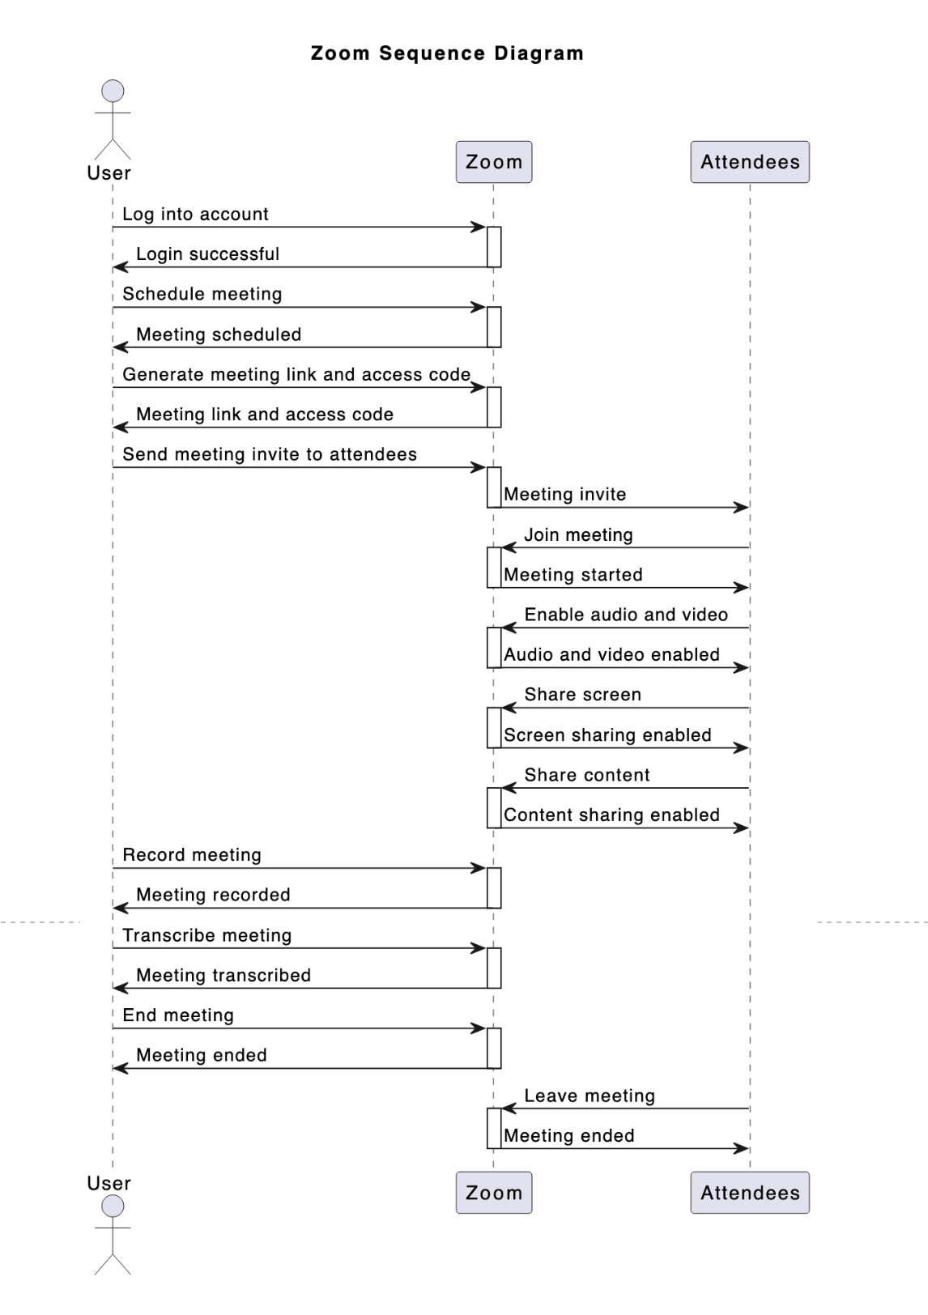

Class Diagram